Web Planning Tool: Screen Samples

1. Opening screen at www.sbccd.org/programreview; click Log On at upper right.
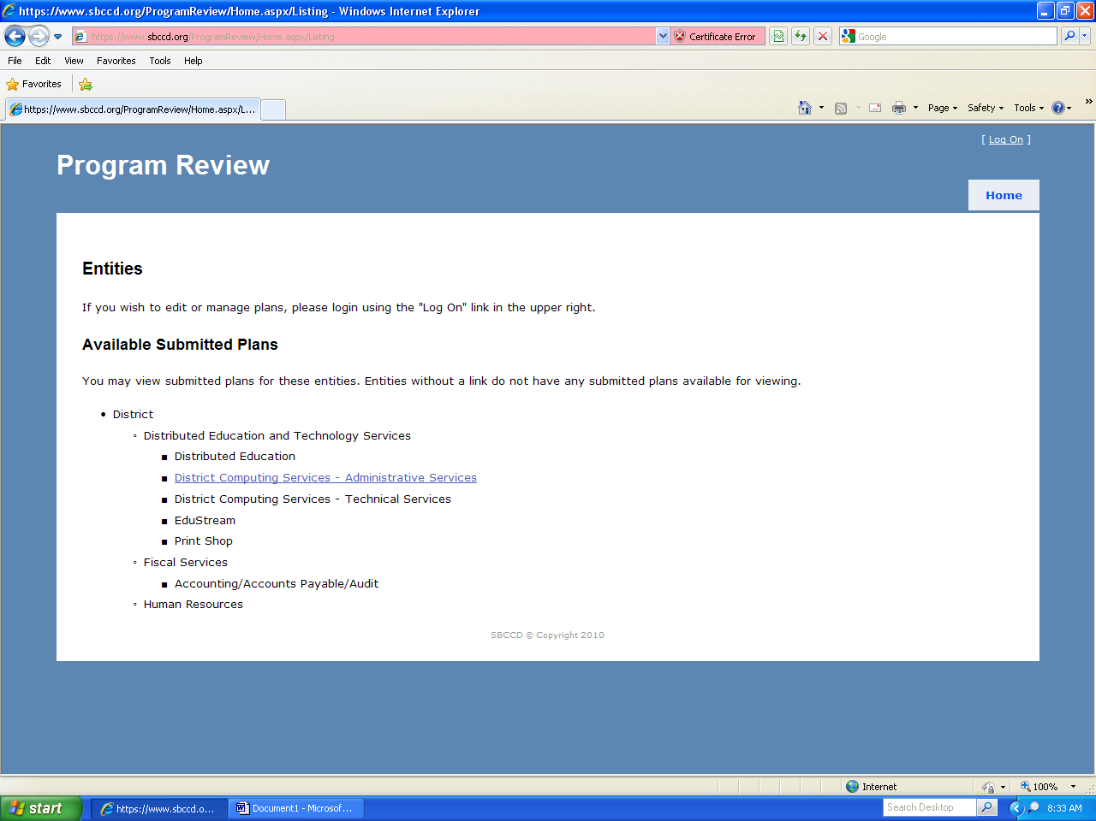

2. Logon screen; enter regular user name and password.
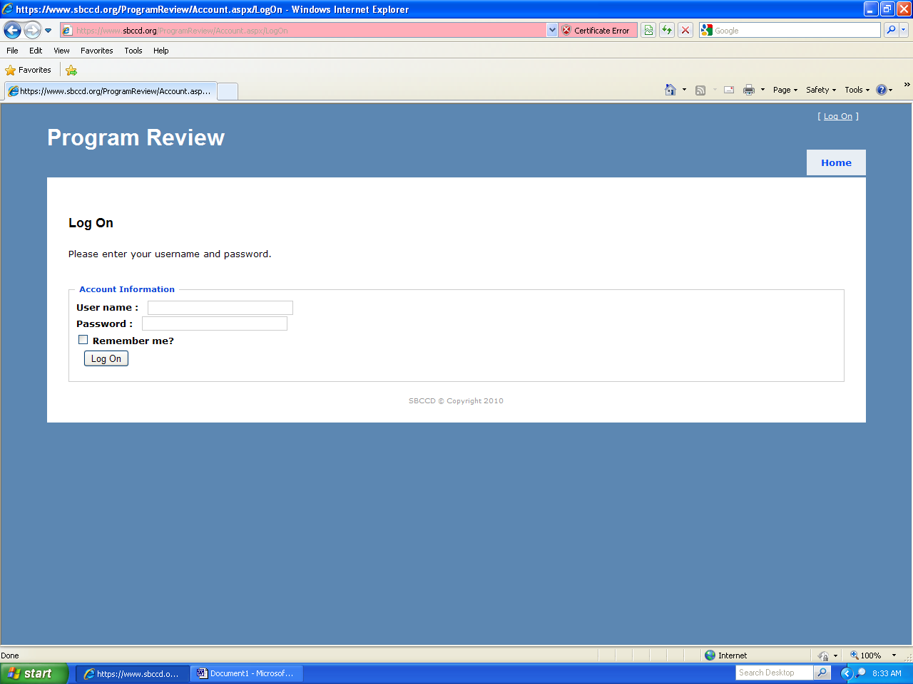
3. Opening screen after logon, parts 1 and 2; shows editing and management rights and available submitted plans. I clicked on DETS link in Direct Management section to go to next screen.
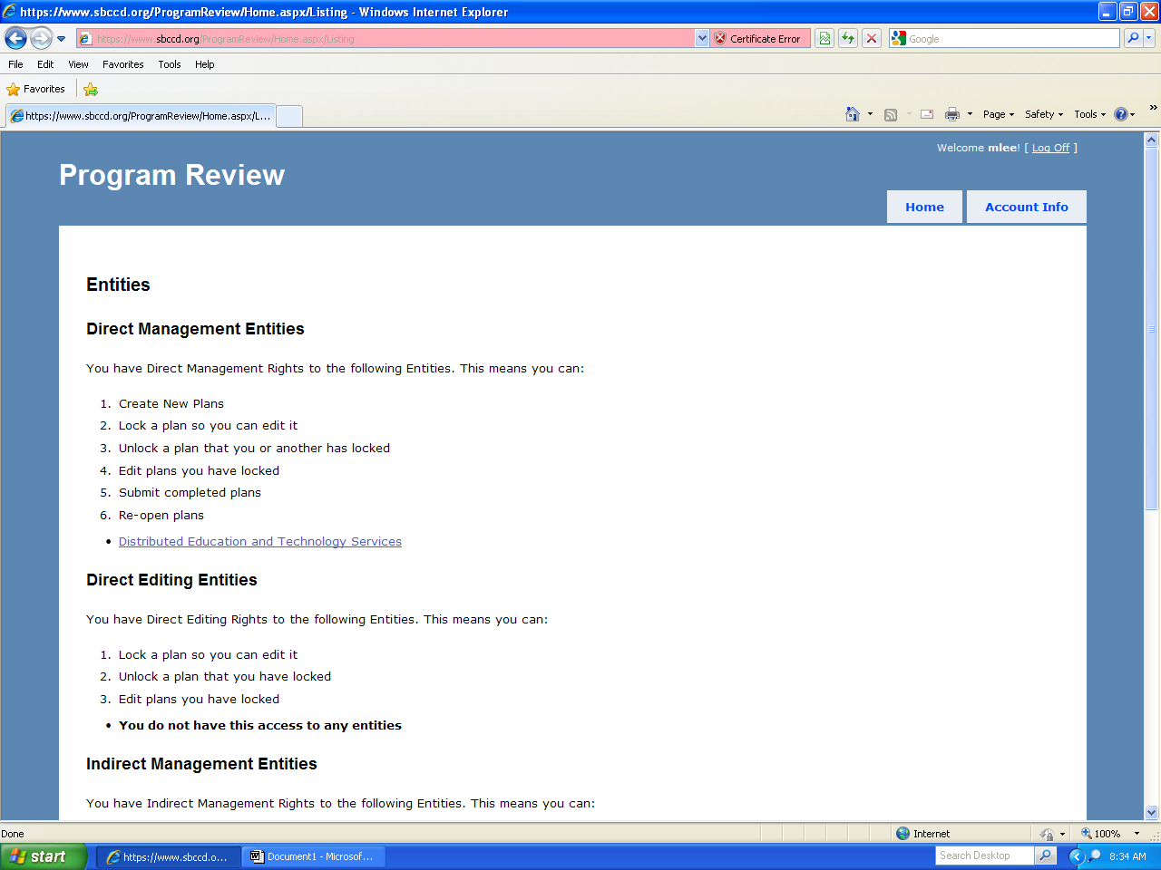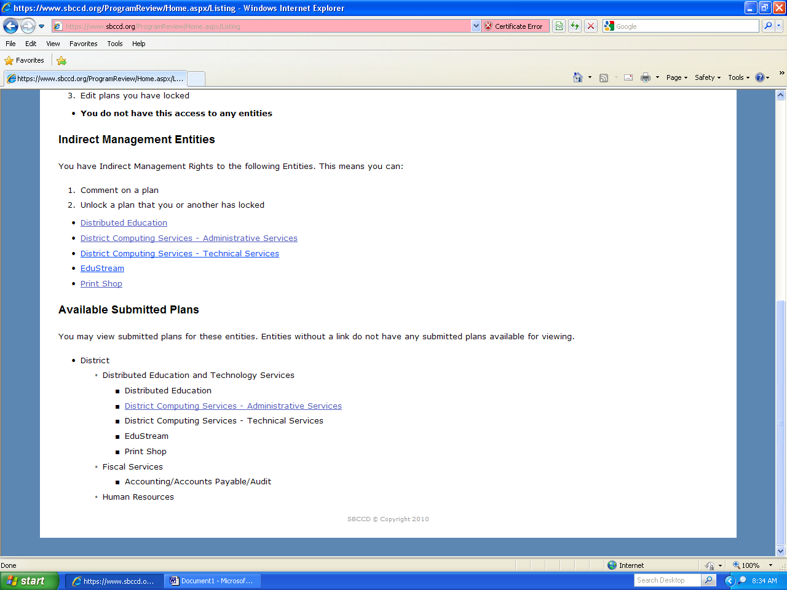

4. Opening screen for plan creation or editing; I clicked on Edit Plan to go to next screen.
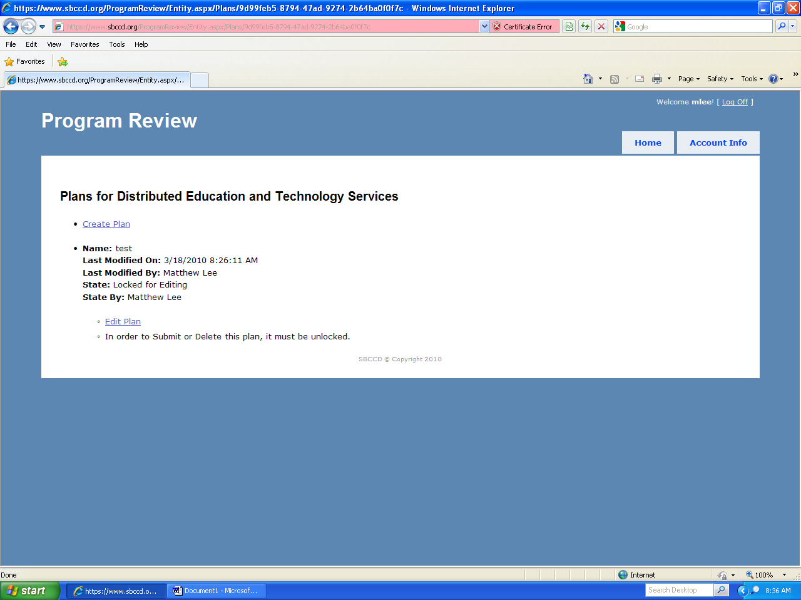

4A. If the plan is not already locked, click Lock plan for editing on this screen
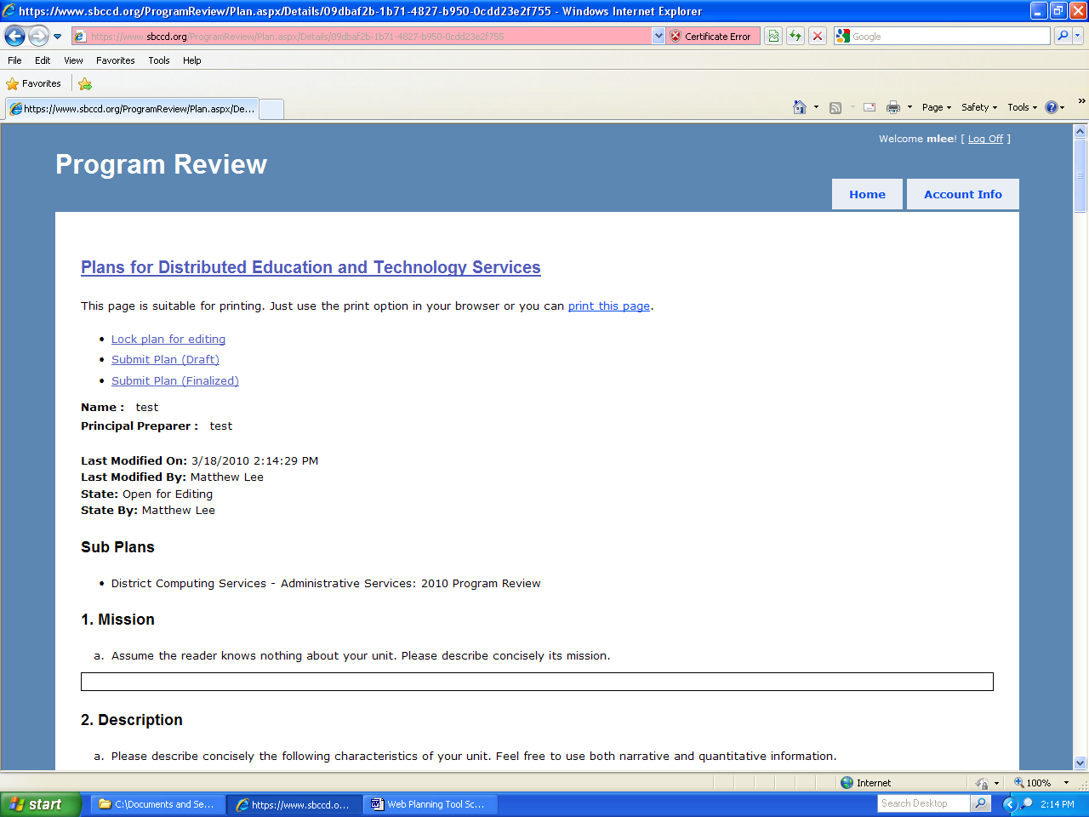

5. Edit Tasks screen; this is your base for all editing and submission functions. I first clicked on Edit texts for plan.
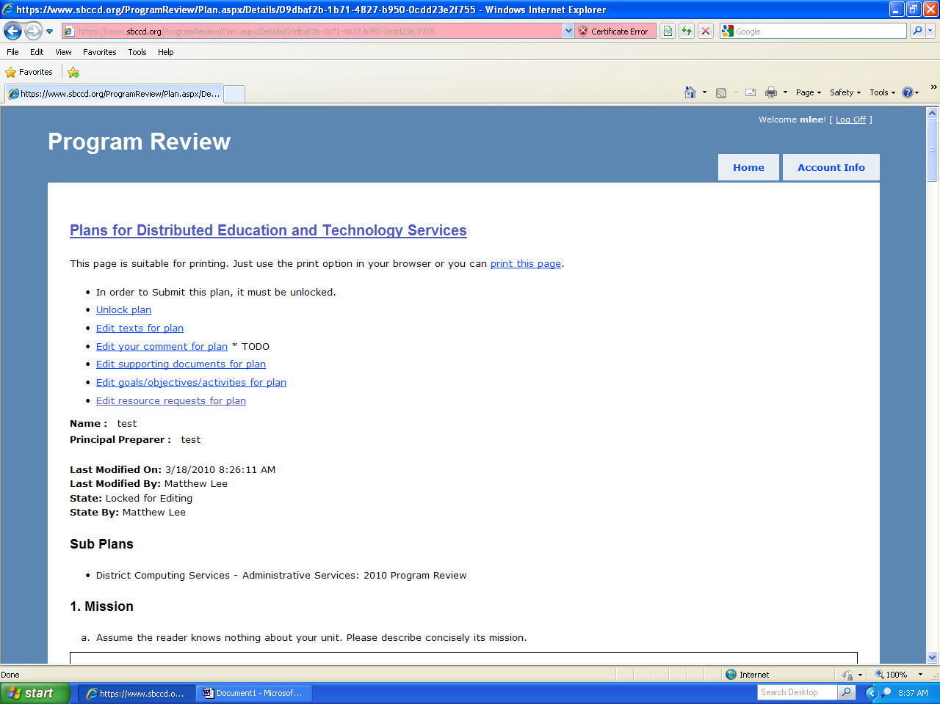

6. Edit texts screen, which mirrors the program review template. This is where you create or edit most sections of the plan, either by cutting and pasting or by direct entry. The rudimentary word processor works best with straight text or outlines, not tables or graphics.
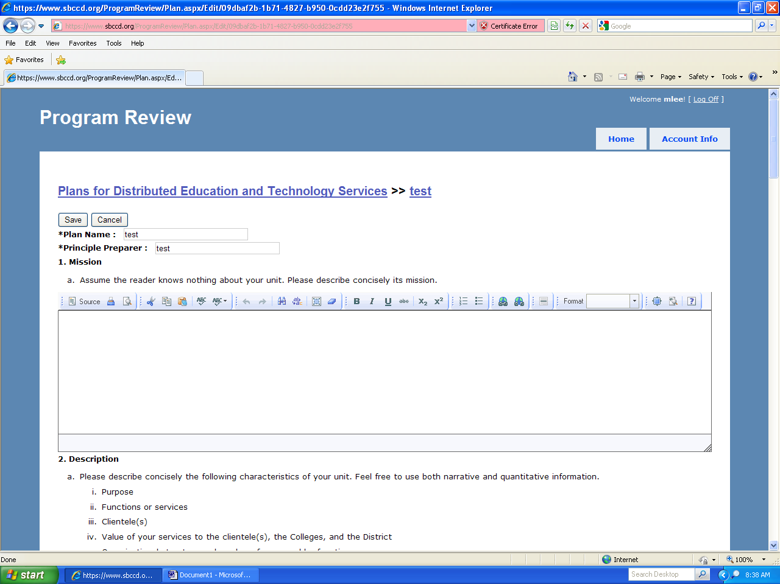
7. Now I have clicked on Edit supporting documents for plan on Screen 5. Add docs here that are too complex to cut and paste directly into the section windows, and refer to them in the applicable window.
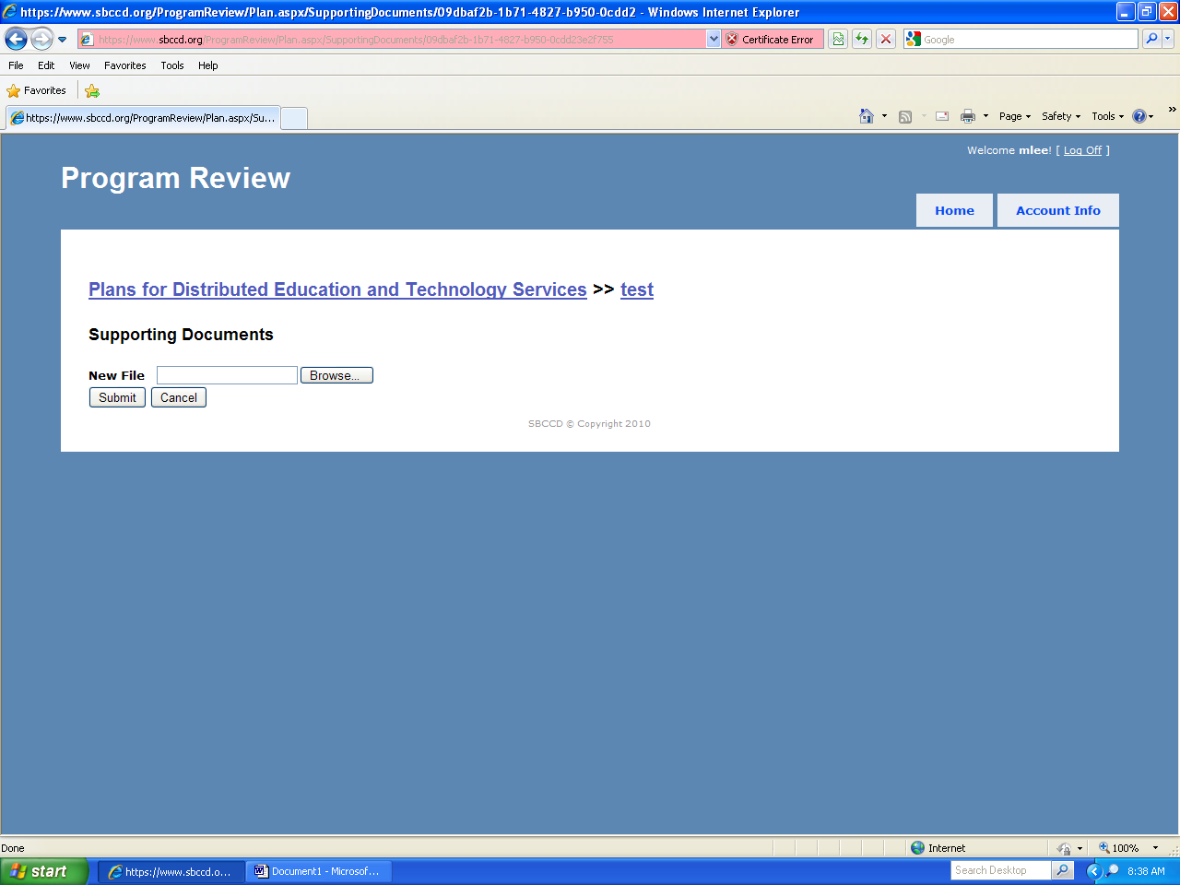

8. Now I have clicked on Edit goals/objectives/activities for plan on Screen 5. Work on all goals, objectives, and activities from here.
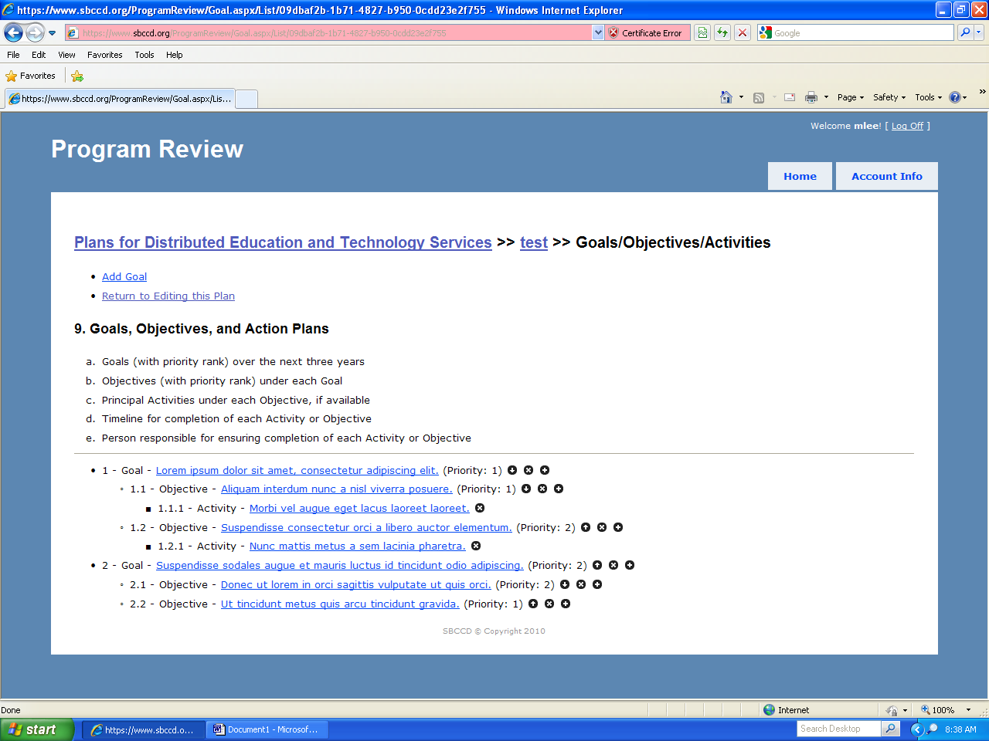

9. Now I have clicked on Add Goal on Screen 8.
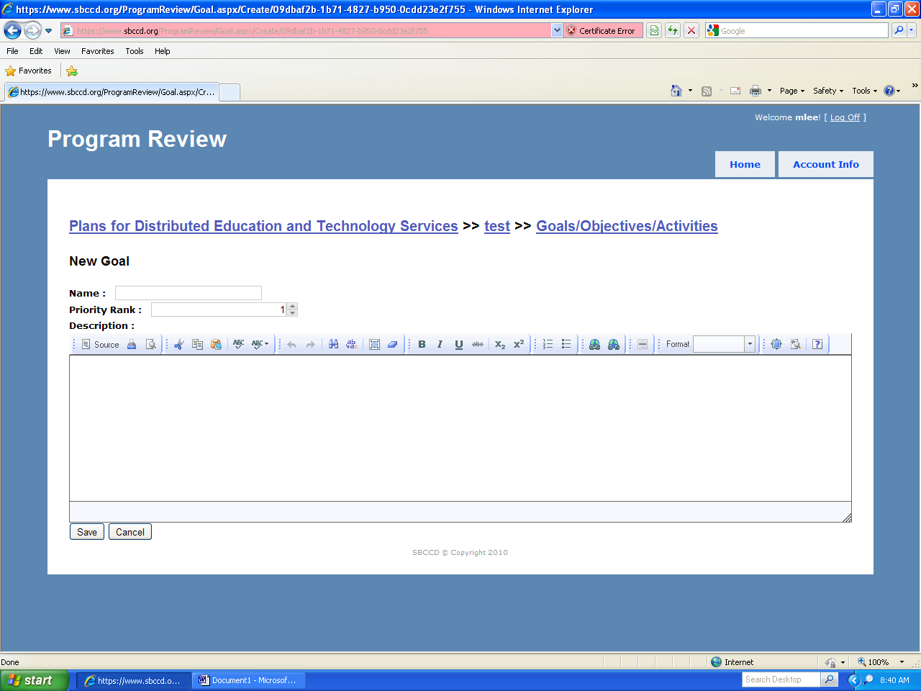

10. Now I have clicked on a Goal on Screen 8 to edit it.
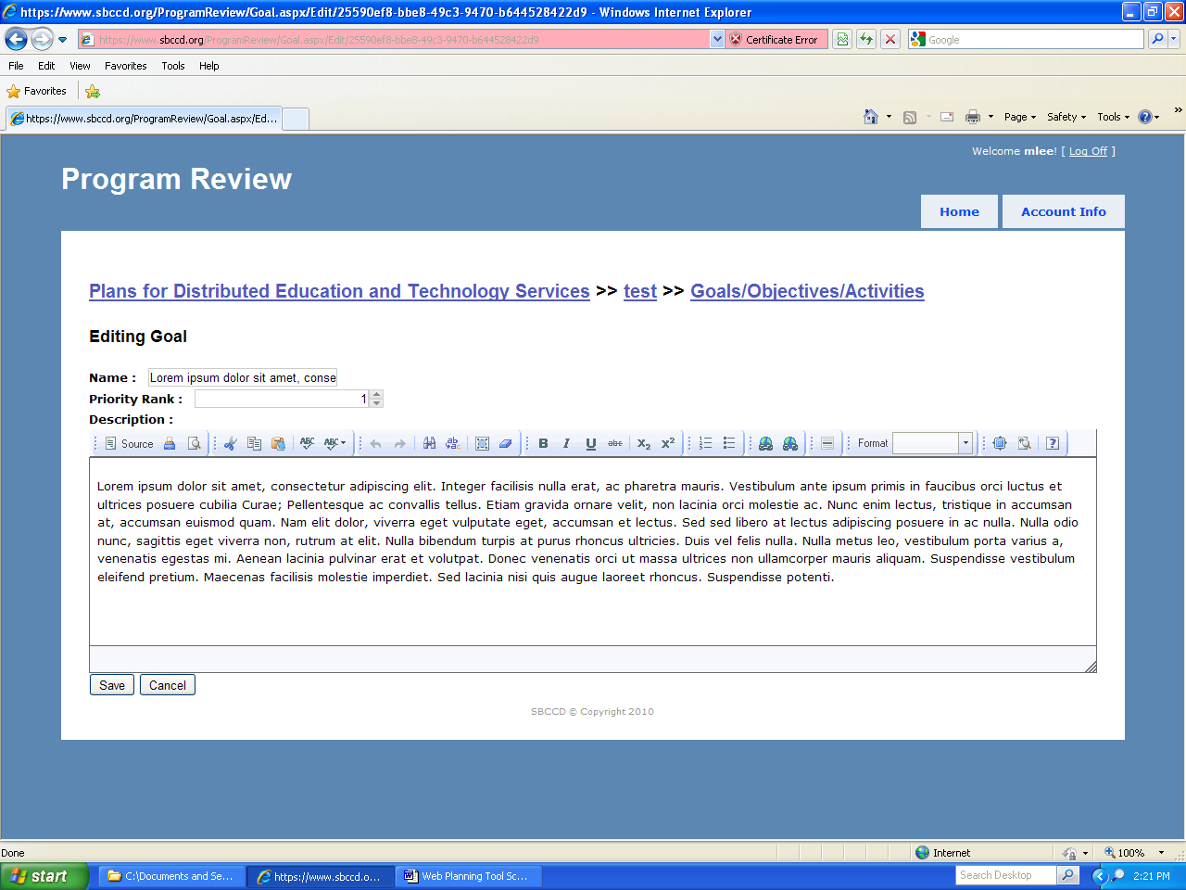

11. Here I have clicked on an objective on Screen 8 to edit it. All the fields shown must be filled in for each objective. Don’t worry about precise dates at this point; just pick a month to start, and an end month that represents a reasonable amount of time to reach the objective.
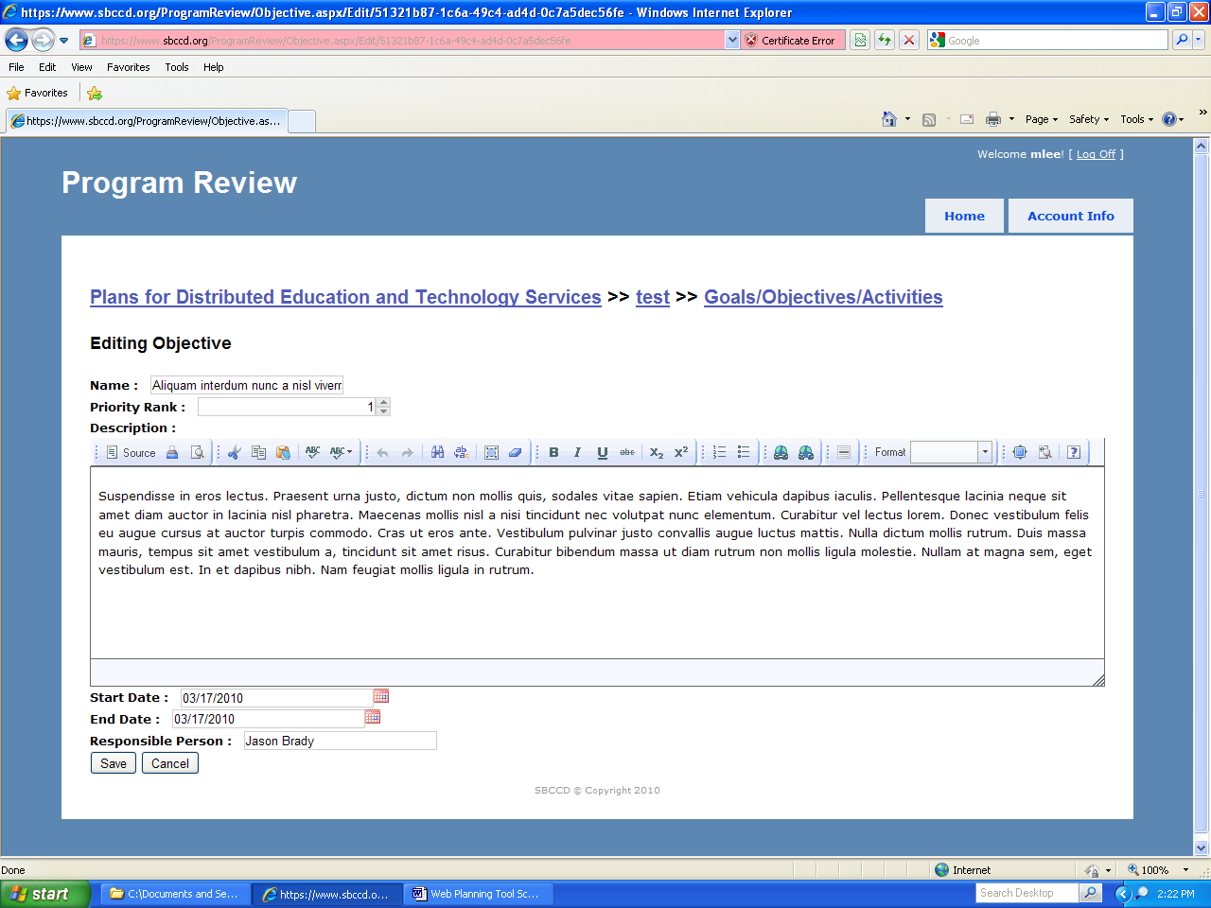

12. And here I have clicked on an activity on Screen 8 to edit it. If you want to list specific activities to help organize the work on the objective, do so here. All fields are optional.
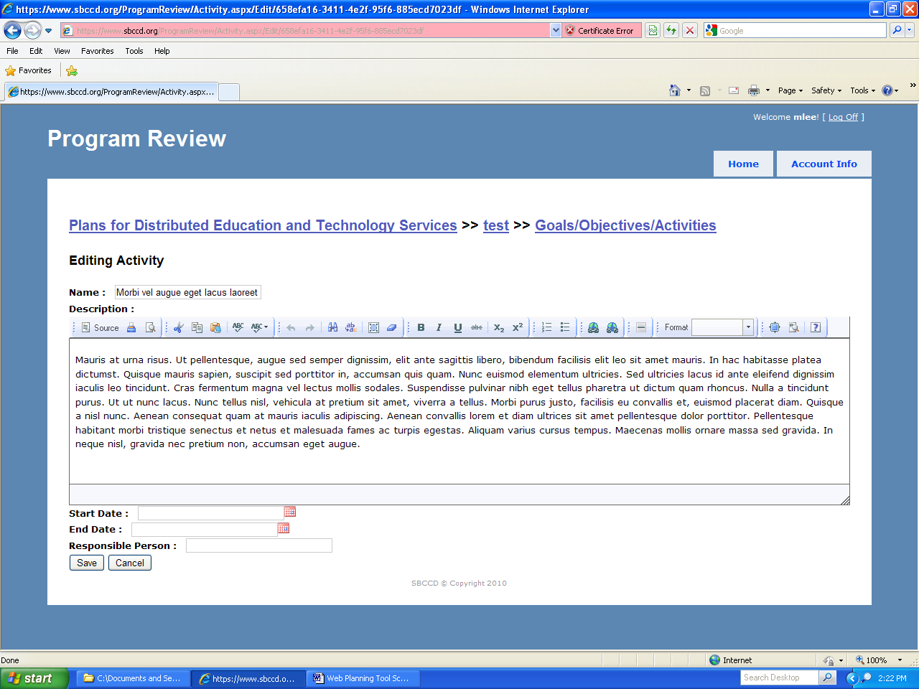

13. Here I have clicked on Edit resource requests for plan on Screen 5. If achievement of an objective requires any additional resources, click the + sign by that objective.
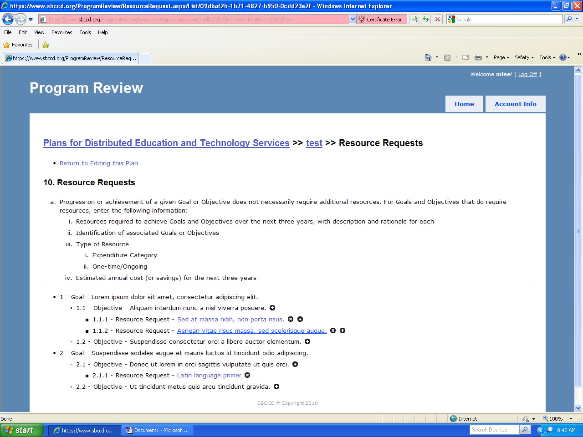

14. I clicked the + sign on screen 13. Enter each resource request separately, including the rationale (based on your objectives), type, category, and estimated cost or savings if available.
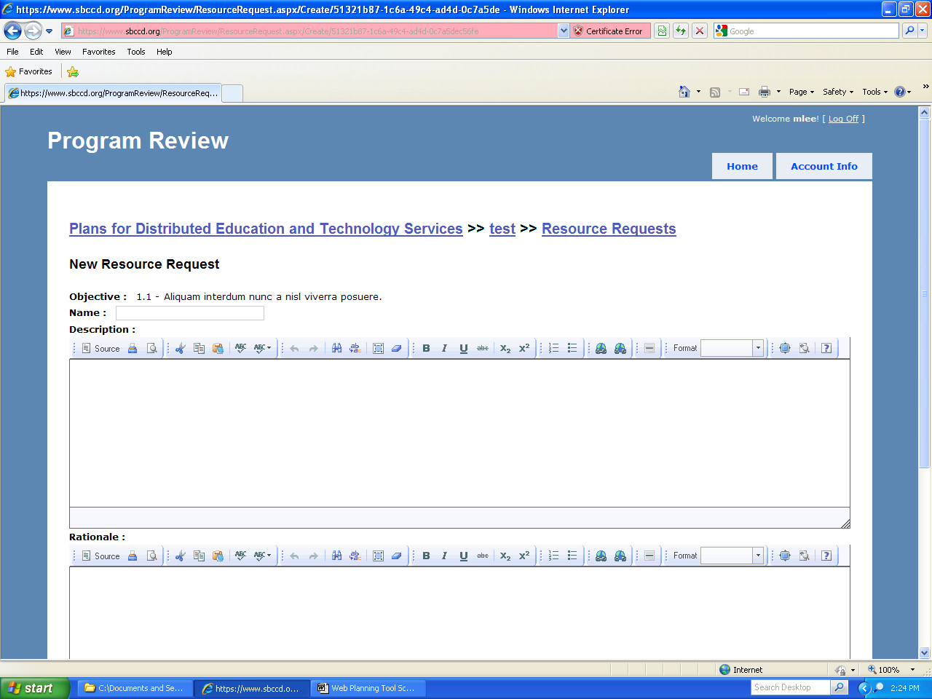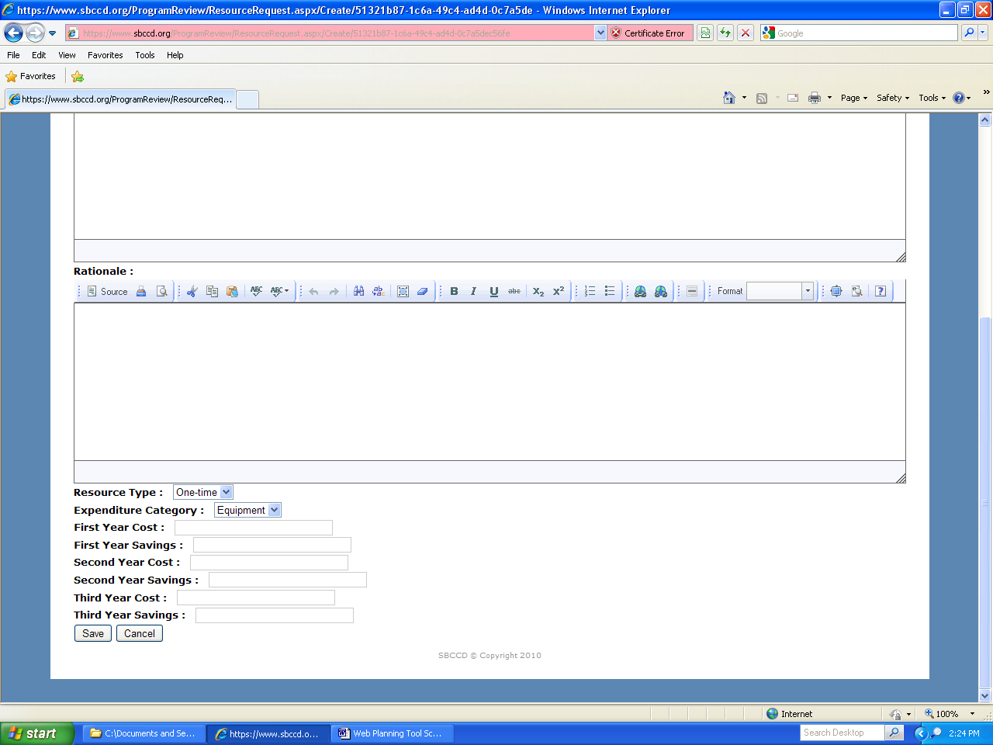

15. Here I clicked on a completed resource request on Screen 13.
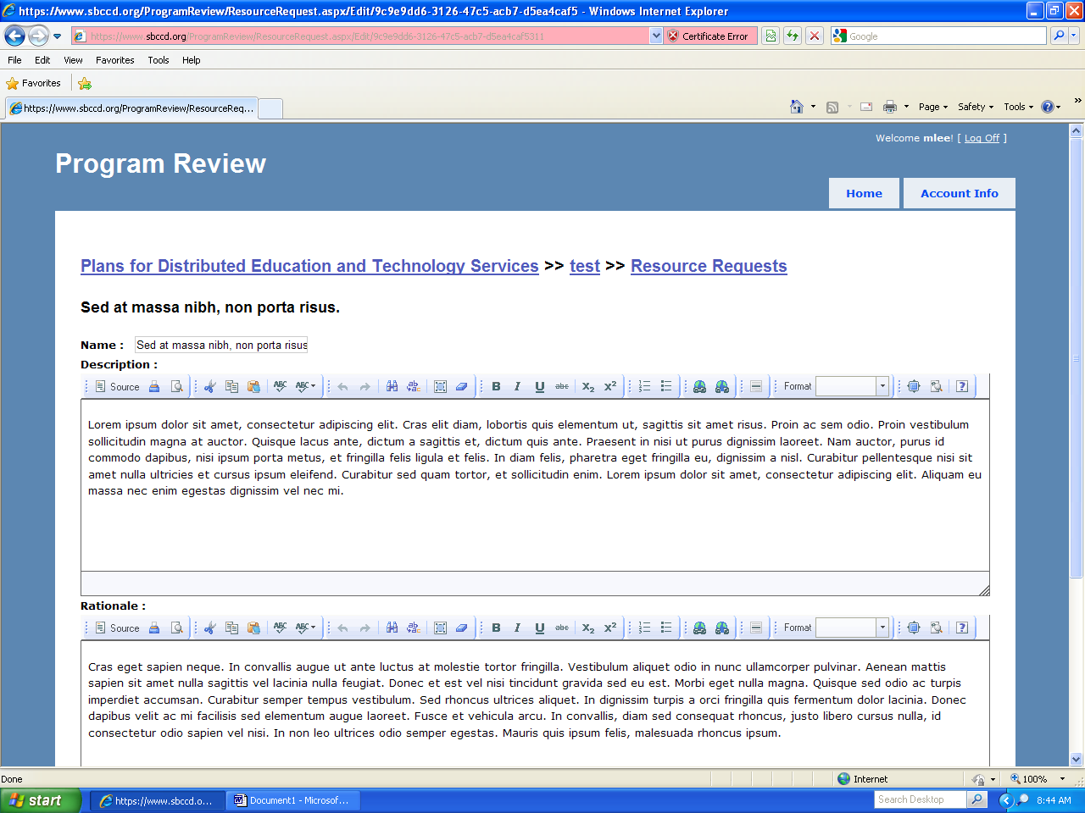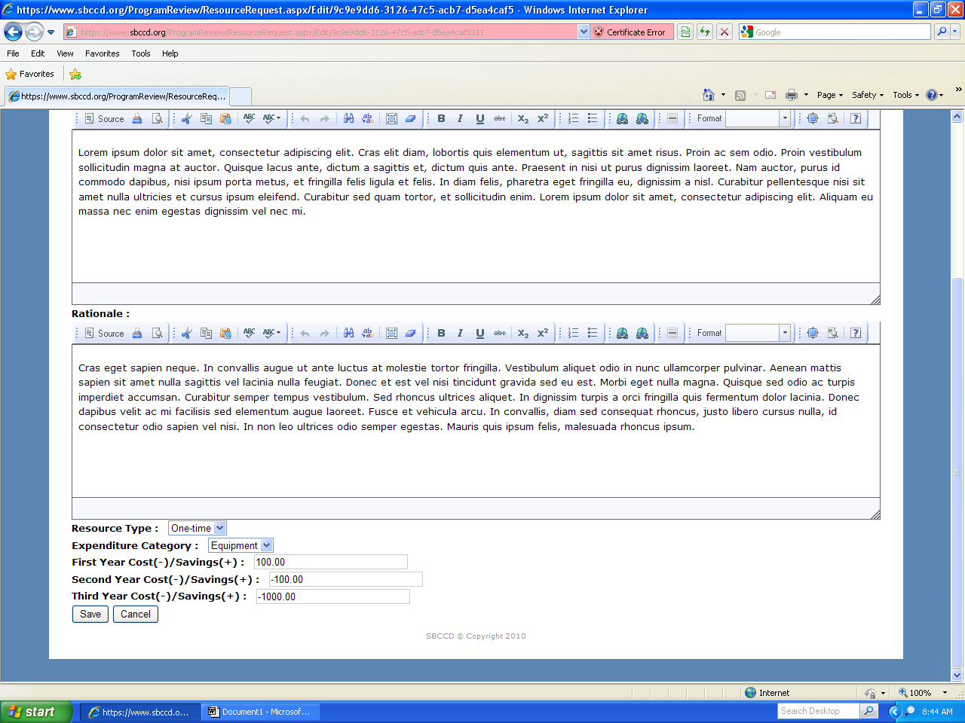

16. Here I clicked on Unlock Plan on Screen 5 so that I could submit the plan.
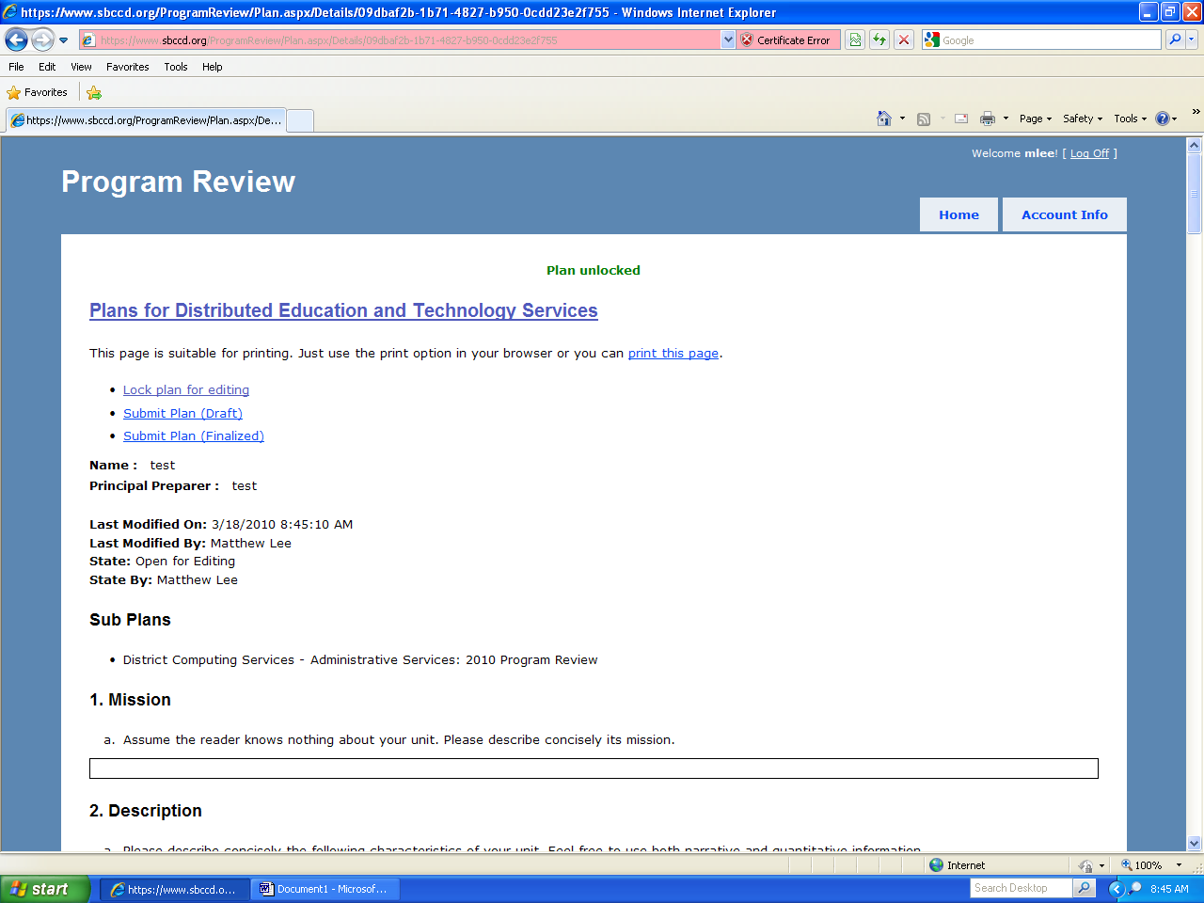

17. Now I have clicked on Submit Plan (Draft) on Screen 16, which you would do if you want feedback on your draft plan.
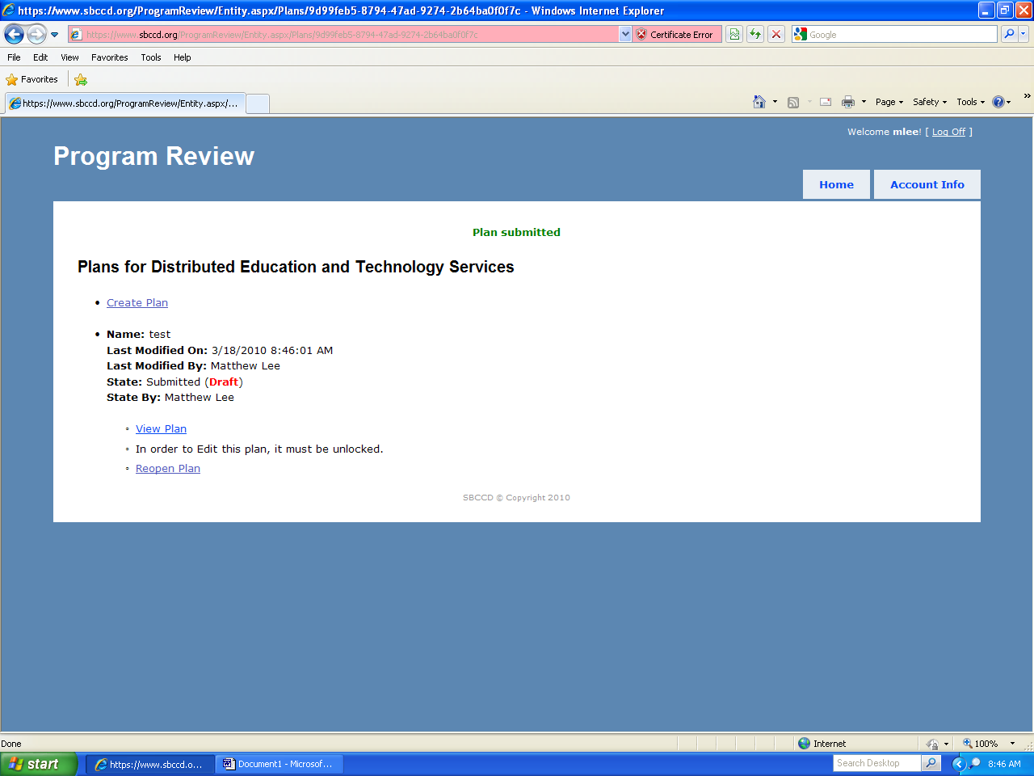

18. Here I have clicked on Submit Plan (Finalized) on Screen 16, the final step in the process for each unit.
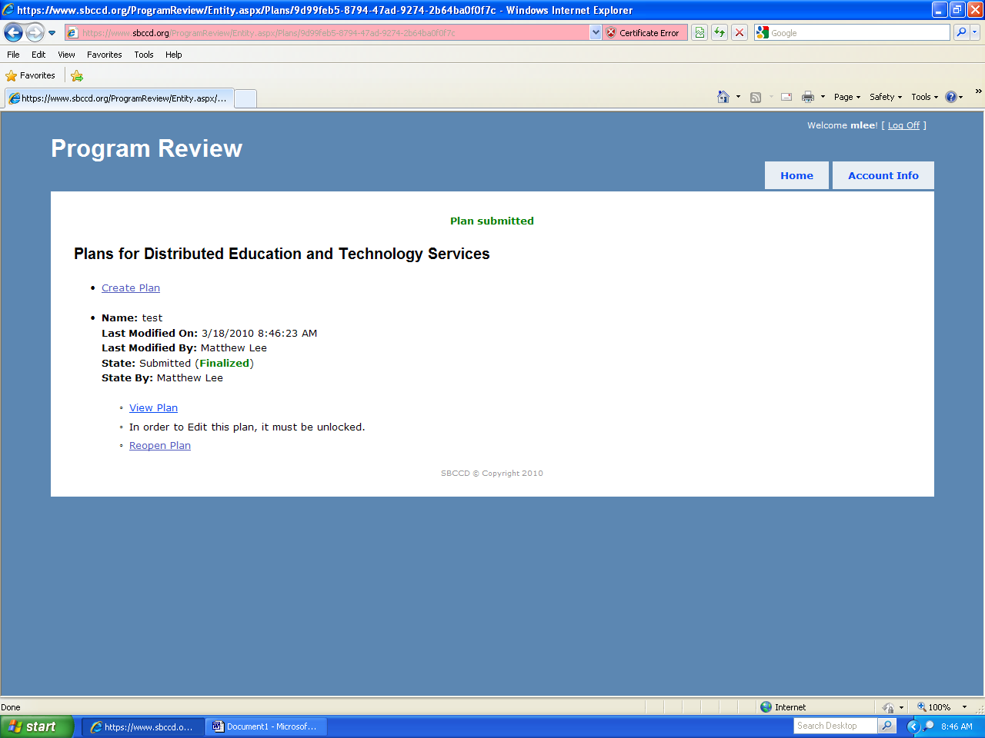

19. I have now clicked Create Plan under DETS on Screen 4.


